**Ahsanullah University of Science & Technology**

**Department of Computer Science and Engineering**

CSE 4102 Computer Networks Lab, Fall 2019, Credit: 1.50

**Lab Final Exam [Set – A]**

**Time: 120 Minutes Marks: 20**

|  |  |
| --- | --- |
| **Name: Devopriya Tirtho** | **ID: 16.02.04.033** |

1. Implement the following topology using EIGRP and fill up the table accordingly: **16**

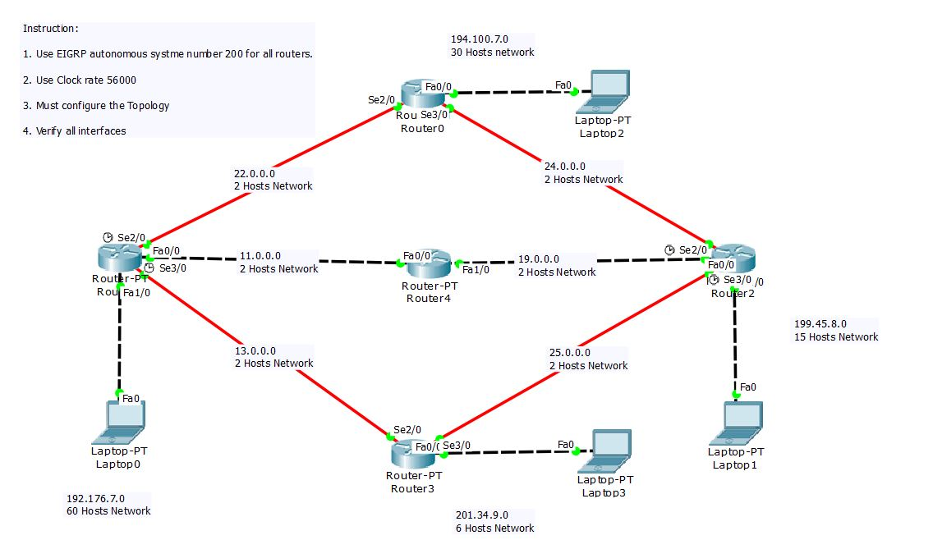

|  |  |  |  |
| --- | --- | --- | --- |
| **Device** | **Interface** | **IP address** | **Subnet Mask** |
| **Router 0** | **Se2/0** | **22.0.0.2** | **255.255.255.252** |
| **Se3/0** | **24.0.0.2** | **255.255.255.252** |
| **Fa0/0** | **194.100.7.1** | **255.255.255.224** |
| **Router 1** | **Se2/0** | **22.0.0.1** | **255.255.255.252** |
| **Se3/0** | **13.0.0.1** | **255.255.255.252** |
| **Fa0/0** | **11.0.0.2** | **255.255.255.252** |
|  | **Fa1/0** | **192.176.7.1** | **255.255.255.192** |
| **Router 2** | **Se2/0** | **24.0.0.1** | **255.255.255.252** |
| **Se3/0** | **25.0.0.2** | **255.255.255.252** |
| **Fa0/0** | **19.0.0.1** | **255.255.255.252** |
|  | **Fa1/0** | **199.45.8.1** | **255.255.255.240** |
| **Router 3** | **Se2/0** | **13.0.0.2** | **255.255.255.252** |
| **Se3/0** | **25.0.0.2** | **255.255.255.252** |
| **Fa0/0** | **201.34.9.1** | **255.255.255.248** |
| **Router 4** | **Fa0/0** | **19.0.0.2** | **255.255.255.252** |
| **Fa1/0** | **11.0.0.1** | **255.255.255.252** |
| **Laptop 0** | **N/A** | **194.100.7.2** | **255.255.255.224** |
| **Laptop 1** | **N/A** | **199.45.8.2** | **255.255.255.240** |
| **Laptop 2** | **N/A** | **201.34.9.2** | **255.255.255.248** |
| **Laptop 3** | **N/A** | **192.176.7.2** | **255.255.255.192** |

**IP Configuration: [Fill up with Routers and End Devices]**

**Configure EIGRP: [Fill up with EIGRP full command accordingly devices]**

|  |  |
| --- | --- |
| **Device** | **Command** |
| **ROUTER 0** | Router(config)#router eigrp 200  Router(config-router)#network 22.0.0.0 0.0.0.3  Router(config-router)#network 194.100.7.0 0.0.0.31  Router(config-router)#network 24.0.0.0 0.0.0.3  Router(config-router)#no auto summary  Router(config-router)#exit |
| **ROUTER 1** | Router(config)#router eigrp 200  Router(config-router)#network 192.176.7.0 0.0.0.63  Router(config-router)#network 13.0.0.0 0.0.0.3  Router(config-router)#network 11.0.0.0 0.0.0.3  Router(config-router)#network 22.0.0.0 0.0.0.3  Router(config-router)#no auto summary  Router(config-router)#exit |
| **ROUTER 2** | Router(config)#router eigrp 200  Router(config-router)#network 199.45.8.0 0.0.0.15  Router(config-router)#network 25.0.0.0 0.0.0.3  Router(config-router)#network 19.0.0.0 0.0.0.3  Router(config-router)#network 24.0.0.0 0.0.0.3  Router(config-router)#no auto summary  Router(config-router)#exit |
| **ROUTER 3** | Router(config)#router eigrp 200  Router(config-router)#network 201.34.9.0 0.0.0.7  Router(config-router)#network 13.0.0.0 0.0.0.3  Router(config-router)#network 25.0.0.0 0.0.0.3  Router(config-router)#no auto summary  Router(config-router)#exit |
| **ROUTER 4** | Router(config)#router eigrp 200  Router(config-router)#network 11.0.0.0 0.0.0.3  Router(config-router)#network 19.0.0.0 0.0.0.3  Router(config-router)#no auto summary  Router(config-router)#exit |

**Test the connectivity using Message Delivary (Success / Failed):**

Router2 to Router0: Successful

Laptop0 to Laptop3: Successful

Router5 to Laptop1: Successful

**Attach the screen shot of your implemented topology, there will be a .PKT file, document file with your answer and also attach the router configuration CLI into a notepad for individual router of your implemented topology when submitting script.

2. Answer the questions with logic. **4**

1. What is the purpose of clock rate in the topology?
2. Is *password password* command being more secure than *secret*

*password*?

1. What is the necessity of Console Line?

**Answer to The Question No. 2(I)**

We use clock rate in routers in a topology. There are two kinds of connection. One is DCE: Data Communication Equipment and DTE: Data Terminal Equipment. At the part of the DCE we need to mention the clock rate by using clock rate command. The clock rate works as the transferring speed of data from DCE part of one router to the DTE part of another router.

The main purpose is to set the speed that the data can avail when transfer from one router to another. If we do not set the speed the connection gets the highest possible speed by default.

As, the network provider sets a speed, we need to transfer data only at that speed.

So, we can say that the purpose of the clock rate is to set the speed at a fixed rate, it will help to figure out if any data is lost or not. Fixing the speed by clock rate serves error detection and packet loss between routers. This is the purpose of clock rate in the topology.

**Answer to The Question No. 2(II)**

The command which enable only password is:

# enable password

This command accepts password only as plain text. The #enable secret commands accepts password and stores it with encryption. If we store password in plain text it is easily getable and one can use it easily. If we store password in an encrypted way, it is more secure.

So, Password password command is not more secure than secret password.

Secret password is more secure.

**Answer to The Question No. 2(III)**

Console line provides the service to make connection with router or switch. It is necessary to configure a router or a switch at a specific port.